

J.E. CAIRNES SCHOOL OF BUSINESS & ECONOMICS
END-OF-MODULE ASSIGNMENT (PART A)
Module Code | MS5106
Student Name and ID | AMIT KUMAR - 24236930

In submitting this assignment, I am aware that it is my responsibility to adhere to the submission guidelines. Please tick (double click… or Yes/No) for the following:
 | Yes | No
I am aware of what the University of Galway plagiarism policy entails.
I have named the assignment file (MS Word docx or doc) to contain my student ID and the module code and assignment number (e.g., 24236930_MS5106_A1.docx).

Declaration for this Assignment Submission:
By submitting this work, I confirm that it is entirely my own and has not been copied or shared in whole or in part with others or generated by AI. I understand that this is individual assignment and that working with another person on an individual assignment, including sharing solutions, ideas, discussing solutions, or approaches to solutions, is considered to be collusion.
I am aware of what the University of Galway plagiarism policy entails. https://www.universityofgalway.ie/academicintegrity/policies/.
Table of Contents
Introduction 2
Understanding Veloxa&Co’s Data Needs and Constraints 3
Technology Options and Comparisons 3
1. Apache Hadoop 4
2. Apache Spark 5
3. Cloud-Based Platforms (e.g., AWS, Google Cloud, Azure) 5
Comparison 5
Recommendation 6
Data system solution 6
Tools Overview & Comparison 7
1. Apache Hive 7
2. Spark SQL 7
3. Cloud SQL Services (e.g., Amazon Athena, Google BigQuery) 7
Comparison 8
Recommendation 8
Conclusion 8
References 8

Introduction
Big data refers to extremely large and complex datasets that traditional tools cannot process efficiently. It is defined by its high volume, velocity, and variety. For companies like Veloxa&Co, which operate in competitive environments, big data offers the opportunity to gain real-time insights and improve decision-making.
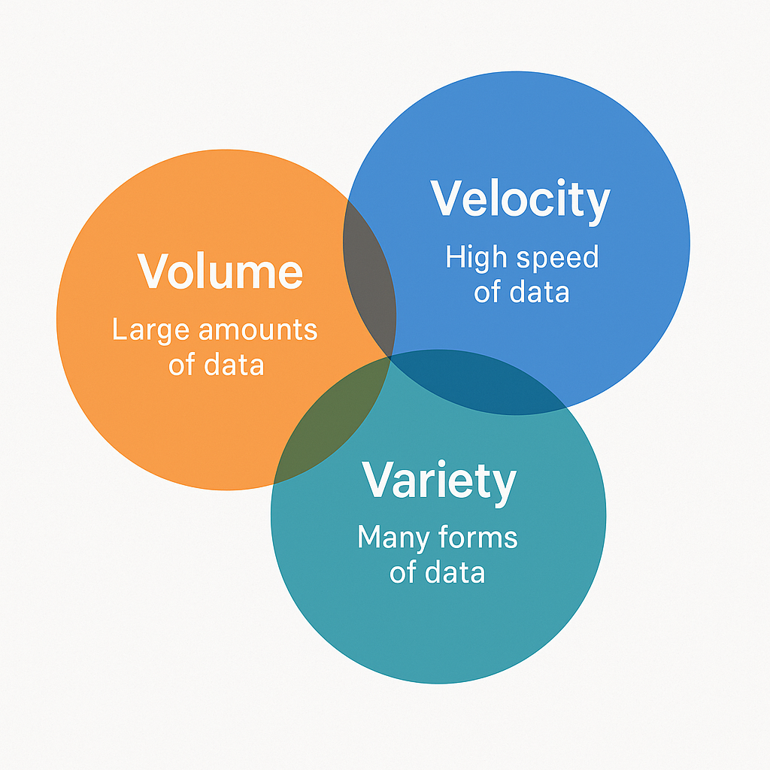
- A cluster is a group of connected computers working together to handle large-scale processing.
- Cloud platforms provide scalable, on-demand computing resources with minimal setup.
- Hadoop and Spark are open-source big data frameworks used for batch and real-time data processing, respectively.

Understanding Veloxa&Co’s Data Needs and Constraints
Veloxa&Co is an e-commerce company that collects huge amounts of data every day from online sales, customer behaviour, and competitor pricing. This type of data is often described as “big data” because it comes in large volumes, arrives quickly, and comes in different formats (structured and unstructured). To stay competitive, Veloxa&Co needs to analyse this data in real time to adjust prices and plan promotions. However, their staff have limited programming knowledge, which makes using traditional big data tools difficult. They also want a system that is easy to scale, cost-effective, and simple enough for non-technical users to understand and use.
The figure below outlines a suggested roadmap Veloxa&Co can follow to implement the recommended big data platform. It includes steps from identifying business goals to monitoring performance and costs.
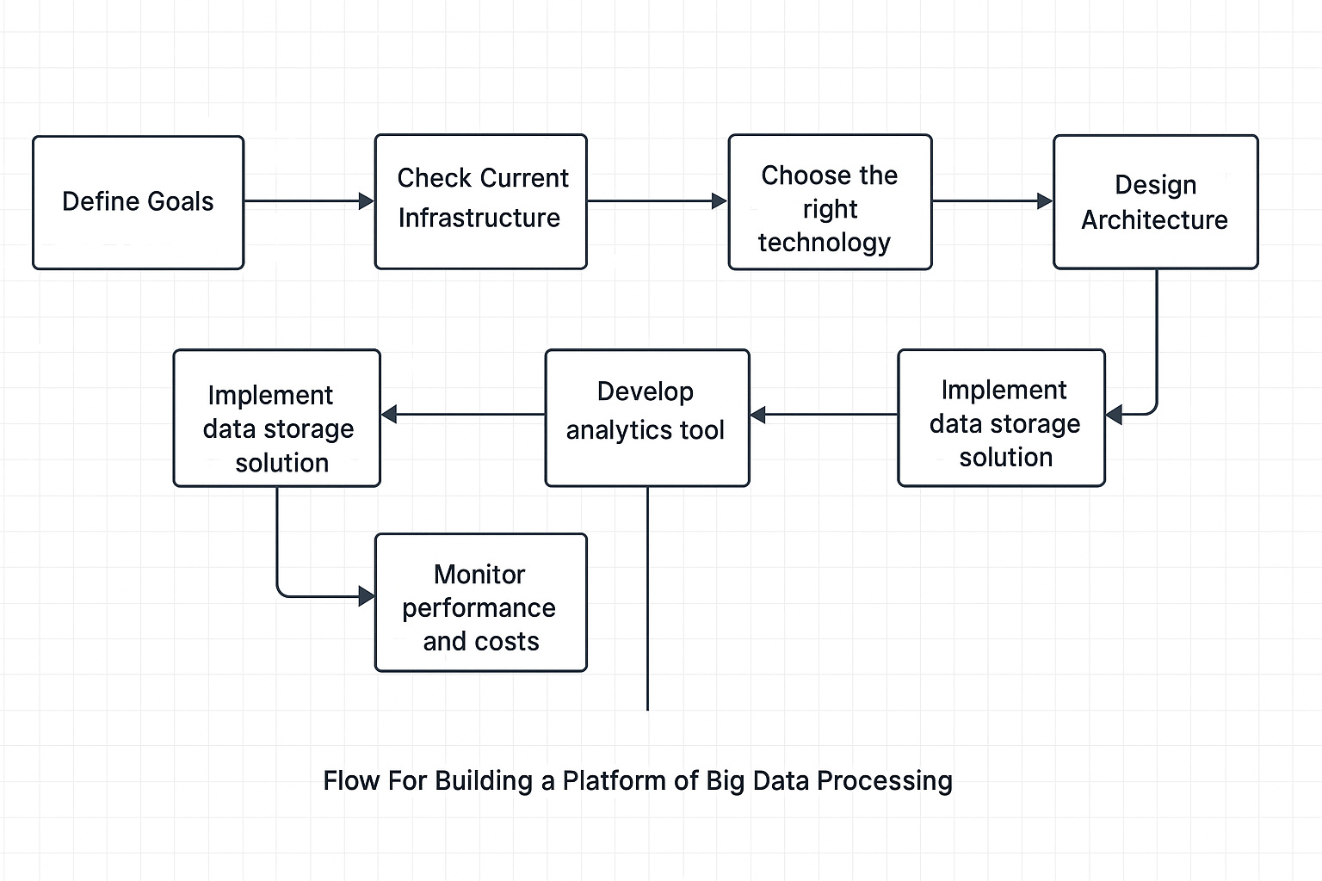

Technology Options and Comparisons
To meet its big data needs, Veloxa&Co can choose from several technologies. Each has different strengths in areas like speed, ease of use, cost, and ability to grow with the business. Below are the most relevant technologies.

1. Apache Hadoop
Hadoop is an open-source framework used to store and process large datasets across many computers. It uses HDFS (Hadoop Distributed File System) to store data and MapReduce to process it in batches. Hadoop is good at handling huge amounts of data and is known for being fault tolerant and scalable [1].
However, Hadoop is not designed for real-time analytics. It processes data in batches, which means results can take minutes or even hours to appear. This delay makes it a poor fit for Veloxa&Co, who need to react quickly to price changes and customer behaviour [2]. Another problem is that MapReduce requires programming knowledge, usually in Java or Python, in which Veloxa&Co’s team is lacking [1].

2. Apache Spark
Spark is a faster, more modern alternative to Hadoop’s MapReduce. It processes data in memory, which makes it up to 100 times faster for certain tasks [2]. Spark also supports real-time processing through its Structured Streaming feature, which means it can analyse data as it arrives, which makes it perfect for real-time pricing decisions.
Spark is also easier to use than Hadoop. It supports high-level APIs in Python, Scala, and Java, and has a module called Spark SQL that allows users to query data using SQL instead of writing complex code [2]. This makes it more suitable for teams with limited programming skills. Spark can also handle multiple types of data tasks, including machine learning, graph analysis, and batch processing, all in one platform [2].
However, Spark uses a lot of memory. Running it efficiently requires good hardware or a managed cloud service, which could increase costs for Veloxa&Co if not managed properly.

3. Cloud-Based Platforms (e.g., AWS, Google Cloud, Azure)
Instead of building and managing their own systems, Veloxa&Co can use cloud services that offer big data tools as managed services. For example, Amazon Web Services offers Amazon EMR for running Hadoop and Spark, and Amazon Athena for SQL queries on large datasets. Google Cloud offers BigQuery, a powerful tool that allows users to run fast SQL queries on massive datasets without needing to manage any servers [3].
Cloud platforms are easy to use, especially for companies without much IT experience. They take care of server maintenance, data storage, and updates. Most cloud platforms also offer user-friendly dashboards and pay-as-you-go pricing, which helps control costs [3].
The main downside of cloud platforms is that costs can grow quickly if data usage is very high. However, for a company like Veloxa&Co just starting out with big data, cloud platforms are a flexible, low-risk option.

Comparison

Technology | Real-Time Processing | Ease of Use | Scalability | Cost | Summary
Hadoop | No | Low (requires coding) | High | Low (open-source, but setup cost) | Great for batch jobs, not real-time
Spark | Yes | Medium (some coding) | High | Medium (memory intensive) | Ideal for real-time and batch analytics
Cloud Services | Yes | High (user-friendly) | Very High | Varies (pay-per-use) | Best mix of speed, ease, and flexibility

Recommendation
Based on Veloxa&Co’s needs, real-time analytics, ease of use, limited programming expertise, and scalability, a cloud-based Apache Spark platform with a SQL interface (like Spark SQL or Hive) is the most suitable solution.
Spark allows real-time processing, which is crucial for tasks like updating product prices based on current sales trends or competitor pricing. Unlike Hadoop’s slower batch model, Spark’s in-memory capabilities offer faster results, helping Veloxa&Co make quick business decisions.
Using Spark SQL allows analysts to write familiar SQL queries instead of learning complex programming. This lowers the technical barrier and helps the company use existing skills effectively [2]. For even easier access, managed cloud services like Amazon EMR (for Spark), Databricks, or Google Cloud Dataproc offer user-friendly dashboards, automatic scaling, and integrated data storage. These platforms handle infrastructure setup and maintenance, reducing complexity and saving time.
Cost-wise, the pay-as-you-go model in the cloud ensures flexibility. Veloxa&Co can start small and scale their system as their data grows. This is especially helpful for businesses that want modern analytics without heavy initial investment [3].
In short, Spark on the cloud with SQL support provides the right mix of speed, simplicity, and scalability, making it the best choice for Veloxa&Co.

Data system solution
Veloxa&Co’s team has experience with structured data and SQL, but limited programming skills. This makes it important to offer tools that support SQL like querying instead of writing complex code. Traditional big data systems like MapReduce or low level Spark APIs can be difficult for non-programmers to use effectively [1]. By using SQL based tools, the staff can easily run queries to analyse sales data, customer behaviour, or pricing trends using skills they already have. SQL like tools also reduce training needs and allow faster adoption across teams. In short, SQL based interfaces help make big data more accessible, efficient, and user-friendly [2].

Tools Overview & Comparison
There are several SQL-like tools available that allow users to query big data without writing complex programs. These tools make it easier for non-programmers to interact with large datasets using familiar SQL syntax. Below are the most relevant ones for Veloxa&Co:

1. Apache Hive
Hive is built on top of Hadoop and uses HiveQL, a language similar to SQL. It allows users to write queries to process large datasets stored in Hadoop Distributed File System (HDFS) [1]. Hive automatically converts these queries into MapReduce jobs. It is especially good for batch processing and data summarisation. However, older versions of Hive can be slow because of their reliance on MapReduce. Newer versions using engines like Tez or Spark have improved performance [2].

2. Spark SQL
Spark SQL is part of Apache Spark and allows users to run SQL queries on big data stored in files or tables. It is faster than Hive and more suitable for real-time analysis [3]. Spark SQL can also be used inside notebooks and integrated with BI tools, making it a good option for data analysts. It works well with other Spark features like machine learning and streaming.

3. Cloud SQL Services (e.g., Amazon Athena, Google BigQuery)
These services allow SQL queries directly on cloud-based data (like files stored in AWS S3 or Google Cloud Storage). Users do not need to manage infrastructure or set up clusters. These tools are very easy to use through web interfaces and are ideal for quick, ad-hoc analysis [4]. However, since pricing is based on the amount of data scanned per query, costs can grow if not carefully managed.

Comparison

Tool | Ease of Use | Performance | Best Use Case | Notes
Apache Hive | High (SQL-like) | Medium (batch) | Large batch queries, summarisation | Slower on large jobs unless optimized
Spark SQL | Medium–High (SQL) | High (in-memory) | Real-time and batch analysis | Faster than Hive, works in notebooks
BigQuery/Athena | Very High (Web SQL) | Very High (cloud) | Ad-hoc analysis with no setup | Pay per query, great for non-tech users

Recommendation
For Veloxa&Co, the best approach is to combine Spark SQL for internal data analysis with a cloud-based SQL servicelike Amazon Athena or Google BigQuery for ease of access. Spark SQL works well with real-time data and integrates seamlessly with Spark’s processing engine, allowing more complex analytics when needed. Meanwhile, Athena or BigQuery provide simple, web-based interfaces where staff can write SQL queries without needing to manage any infrastructure. This setup allows both technical and non-technical team members to use big data effectively while keeping the system fast, flexible, and user-friendly.

Conclusion
Veloxa&Co needs a big data solution that is fast, easy to use, and scalable. After comparing several technologies, the best option is to use Apache Spark on a cloud platform, combined with SQL-based tools like Spark SQL and a cloud service such as Amazon Athena or Google BigQuery. This setup offers real-time analytics, simple SQL interfaces for staff without programming experience, and flexibility to grow as the company expands. It also avoids high upfront costs by using a pay-as-you-go model. This approach will help Veloxa&Co make smarter, faster decisions using their data more effectively.

References
- MS5106 Lecture Notes, University of Galway, 2025.
- Zaharia, M., Chowdhury, M., Franklin, M.J., Shenker, S. and Stoica, I. (2012) ‘Resilient distributed datasets: A fault-tolerant abstraction for in-memory cluster computing’, Proceedings of the 9th USENIX Conference on Networked Systems Design and Implementation (NSDI), pp.
- Thusoo, A., Sarma, J.S., Jain, N., Zheng, Z., Chaudhuri, S., Liu, H., and Murthy, R. (2010) ‘Hive – A Petabyte Scale Data Warehouse Using Hadoop’, Proceedings of the 26th International Conference on Data Engineering (ICDE), IEEE, pp.
- Bughin, J., Chui, M. and Manyika, J. (2010) ‘Clouds, big data, and smart assets: Ten tech-enabled business trends to watch’, McKinsey & Company. Available at: https://www.mckinsey.com/mgi/overview/in-the-news/clouds-big-data-and-smart-assets.

